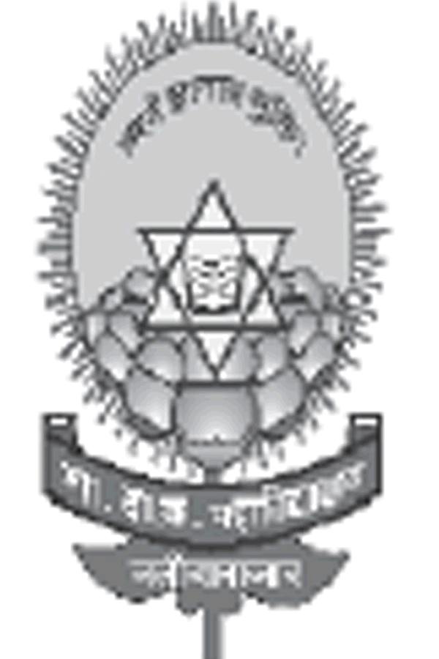
Government Dau Kalyan Arts & Commerce Postgraduate College, Baloda Bazar, Chhattisgarh

7.1.11 - Institution celebrates / organizes national and international commemorative days, events and festivals.
Institution celebrates/ organizes national and international commemorative days, events and festivals. National festivals play an important role in planting seed of Nationalism and Patriotism among people of India. Our institution celebrates these events with great enthusiasm to commemorate the ideology of nationalism and to pay tribute to our great National Leaders. The Faculty, Staff and Students of the institution all come together under one umbrella to celebrate these occasions and spread the message of Unity, Peace, Love and Happiness throughout.
Republic day- The institution celebrates Republic day on 26th January every year, commemorating the adoption of Indian constitution and spreading the message that India is the largest democratic country in the world. This is a day to remind the students about the constitution of the country and the need to abide by it at all times.
Independence Day is celebrated every year on 15th of August, parades and flag hoisting is organized and is celebrated to mark freedom of India from British rule. The institution encourages students to remember our national leaders and their sacrifices.
Gandhi Jayanti is celebrated every year on 2nd October to understand the ideology of our great leader Mahatma Gandhi wherein pledge is taken by students and staff. In today’s times we inspire students of our institution to follow the Gandhian ideologies of truth and non-violence and inspire them to contribute towards the peace and prosperity of the Nation.
International Yoga day is celebrated on 21st June every year. The yoga Instructor organizes the yoga camp and a speech is conducted to make everyone aware on how Yoga embodies unity of mind and body; thought and action; restraint and fulfilment.
Voters Day is celebrated on 25th January wherein the students are given awareness on their duties and rights as a loyal citizen.
National Youth Day, also known as Vivekananda Jayanti, is celebrated on 12th January, being the birthday of Swami Vivekananda. In 1984 the Government of India declared this day as National Youth Day and since 1985 the event is celebrated in India every year and in our institution National Youth Day is always celebrated.
December 01 International Aids day Celebration and awareness.
No Tobacco Day Celebration and awareness.
International Women’s Day In the respect of women every year International Women’s Day is celebrated. For the safety of female students awareness programmes were organised by the college frequently.
Several departments are also actively involved in organising events involving students, and staffs:
- 10 December International Human Rights Day by Law Department.
- 26th November Constitution Day by Law Department.
- Hindi Divas by Hindi Department.
- Rajya Dhasha Divas
- National Mathematics Day by Maths Department.
- National Science Day is celebrated.
- NCC Day by NCC
- NSS Day by NSS
- Red Cross Day.

