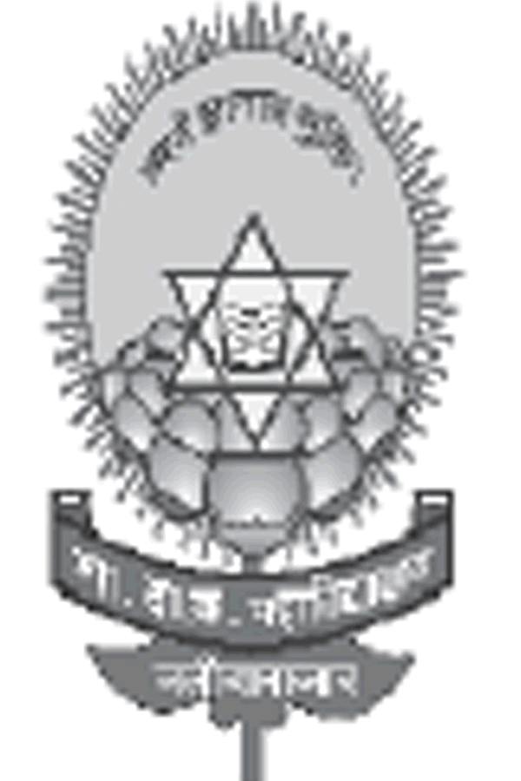
Government Dau Kalyan Arts & Commerce Postgraduate College, Baloda Bazar, Chhattisgarh

7.1.3 Describe the facilities in the Institution for the management of the following types of degradable and non- degradable waste.
This initiative was taken in view of the National Mission on Clean & Green Environment followed by Swatch Bharat Abhiyan. In our institution plastic is strictly band, dry and wet waste garbage are separately collected, there is proper collection for waste water. As an institution we take steps in whatever small way we can to support the global cause by initiating few but concrete step towards the goals.
Solid Waste Management
Solid waste is collected from the college each morning by housekeeping staff in separate containers and assembled at the waste yard marked as garbage collection pit at the end of the camps, separate garbage collection bins are kept for dry and laboratories waste. The uses of dust bins are compulsory in the institution. For solid waste management compost pit is made in which all degradable waste is dumped down. The degradable waste is converted into soil manure/fertilizer after processing this manure is used in our own garden are also made available to all staff members.
Liquid Waste Management
For liquid waste management the institution is highly concern towards stopping the wastage of water. Students and staff are encouraged for proper use of water and proper care is taken for the appropriate use of water. Water from wash basin/bathroom is stored in tank which further goes into the soil which helps in the increase the ground water level.
Solid Waste Management

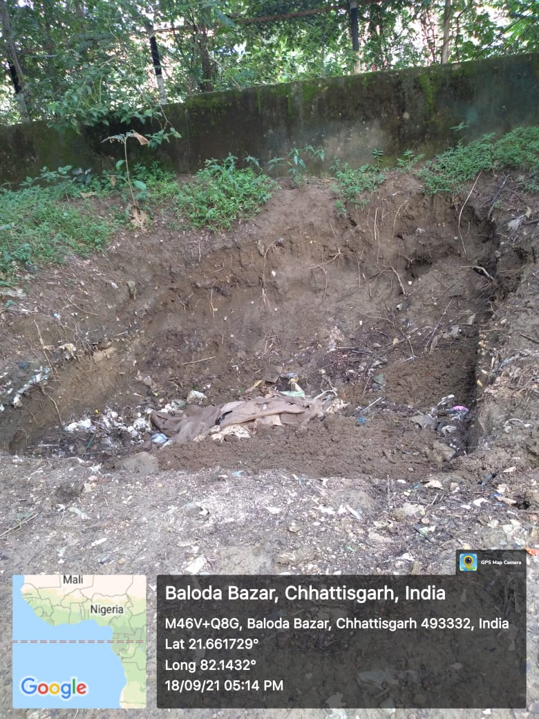
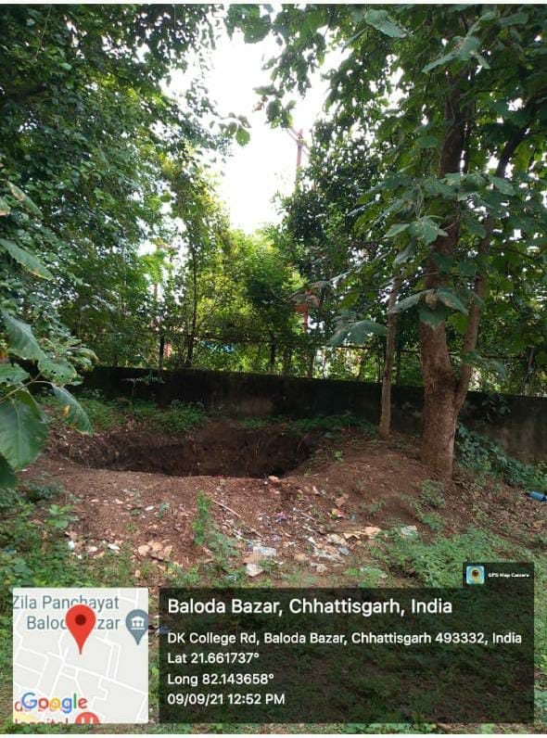
Chemical Waste Storage
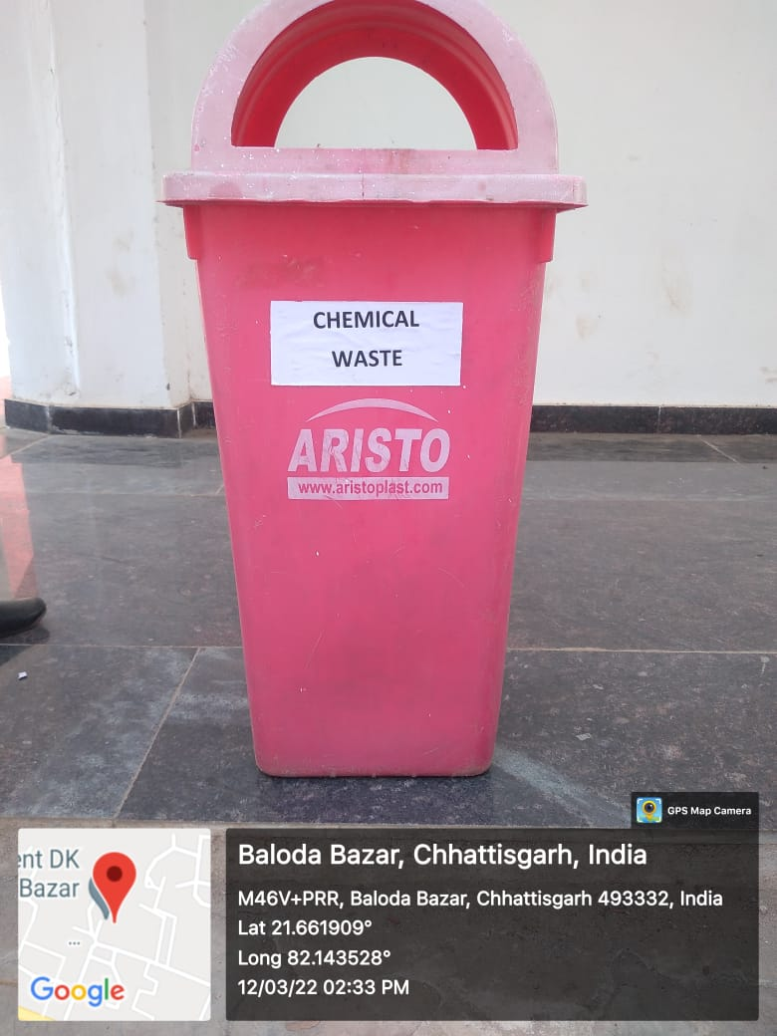
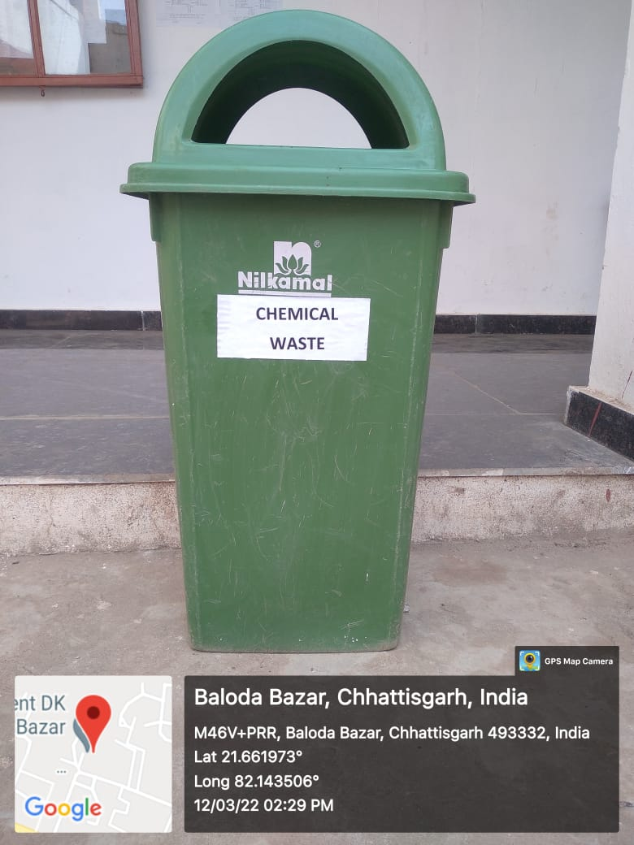
Dry waste Storage
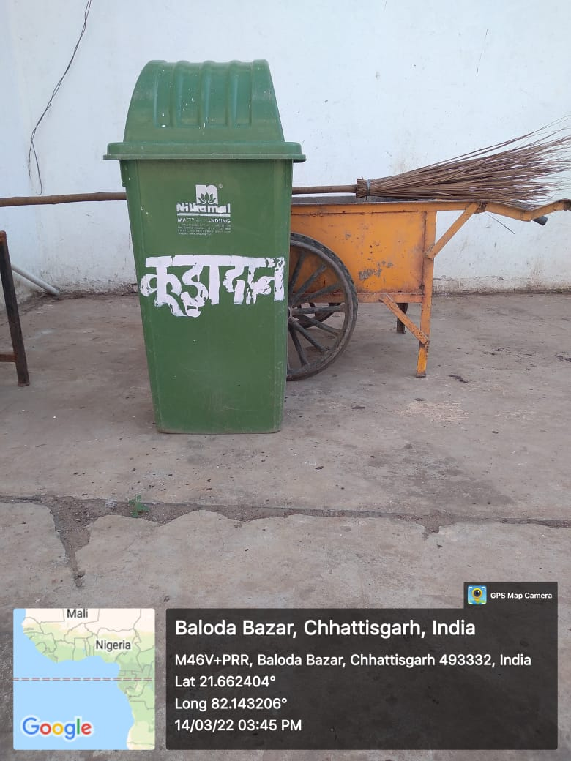
Liquid waste Management
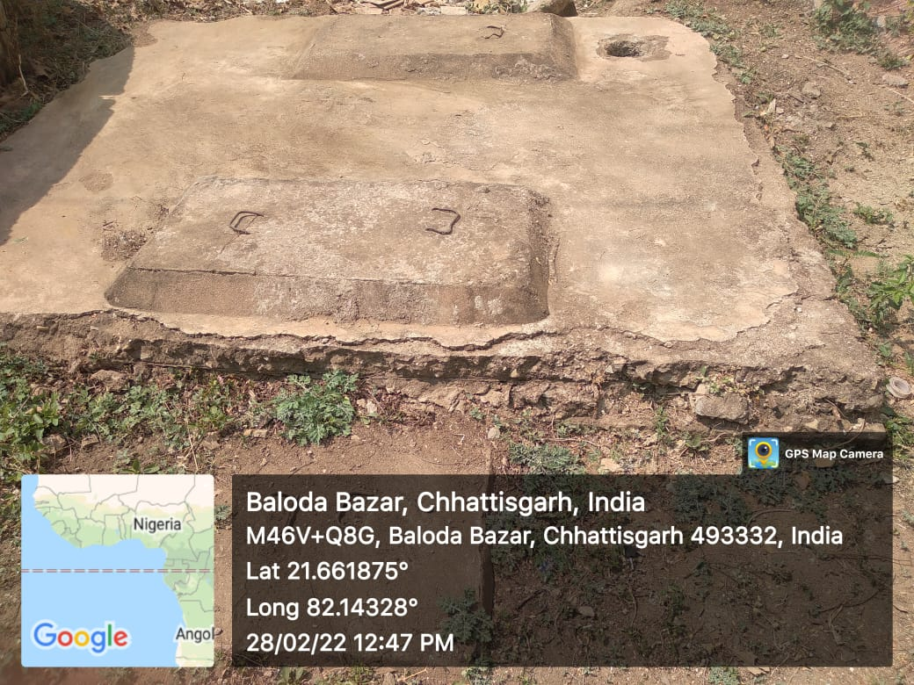
Lemon plant grown from compost pit manure

