Government Dau Kalyan Arts & Commerce Postgraduate College, Baloda Bazar, Chhattisgarh

7.1.5 Green Campus initiatives
Government Dau Kalyan Arts & Commerce Postgraduate College, Baloda Bazar is known for its beautiful landscaping with trees and plants. 35% of the campus is covered with greenery. The college campus includes green spaces embellished with several native and non native tree species, fruit trees, flowering and decorative plants and trees and plants of medicinal values. The biodiversity across campus not only ensure a noise free campus off the main road but also maintain a cool environment inside the college premises. The trees attract a variety of birds, insects, and other fauna.
Plastic Ban
Notices are displayed in campus to refrain from the use of plastics. In addition security is alerted to stop plastics entry on campus in any form. The whole campus is monitored for all such usage and attempt is made to completely eradicate any form of plastic on campus. Paper bag are encouraged for use by students and staff members.
Use of bicycles

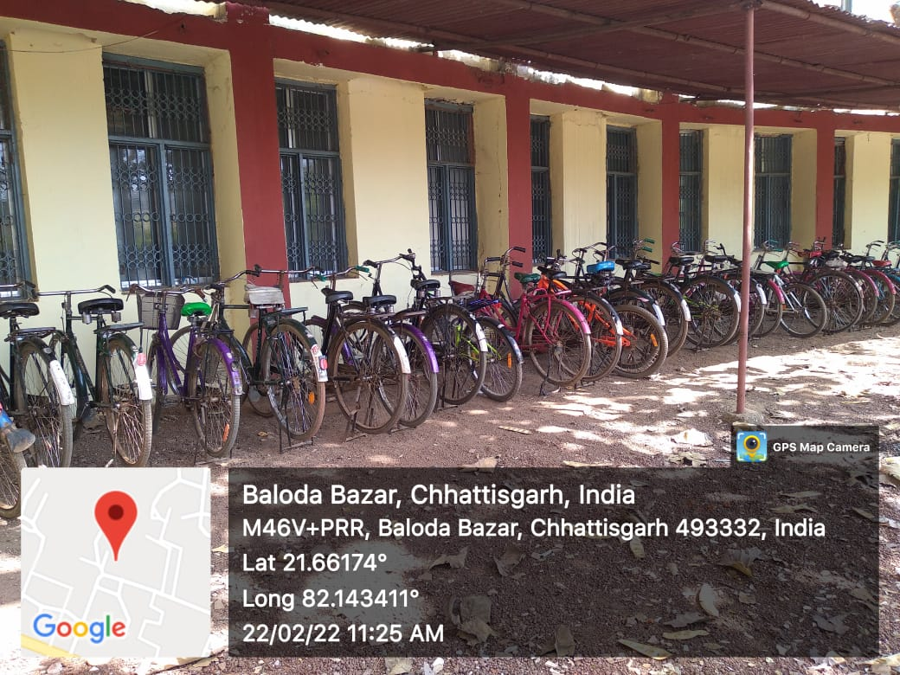

Ban on use of Plastic

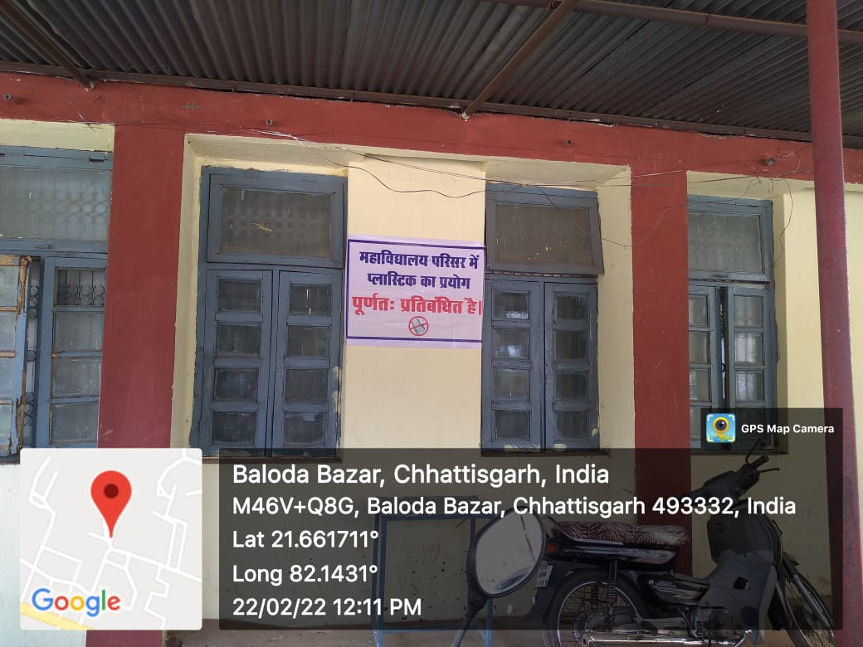
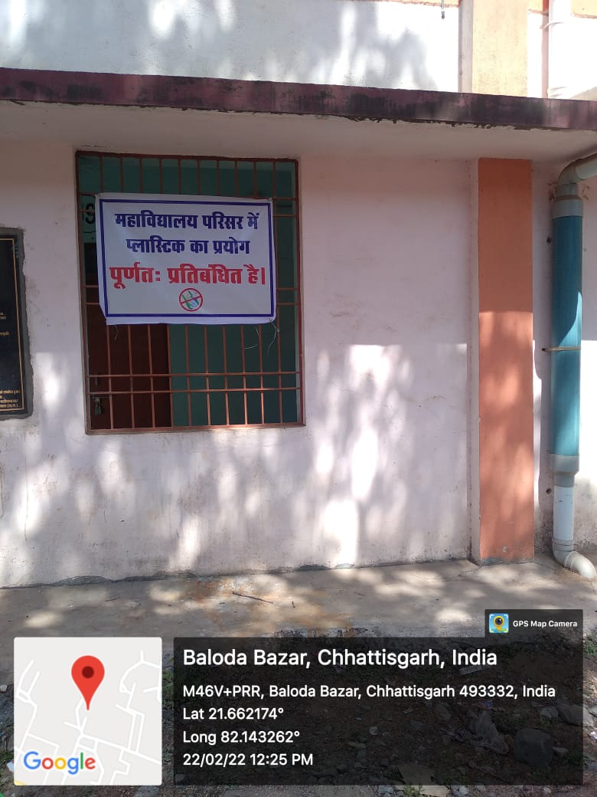

Landscaping with trees and plants

