** Government Dau Kalyan Arts & Commerce Postgraduate College, Baloda Bazar, Chhattisgarh**

**7.1.7 The Institution has disabled-friendly, barrier free environment.**

Ramps for easy access to classroom

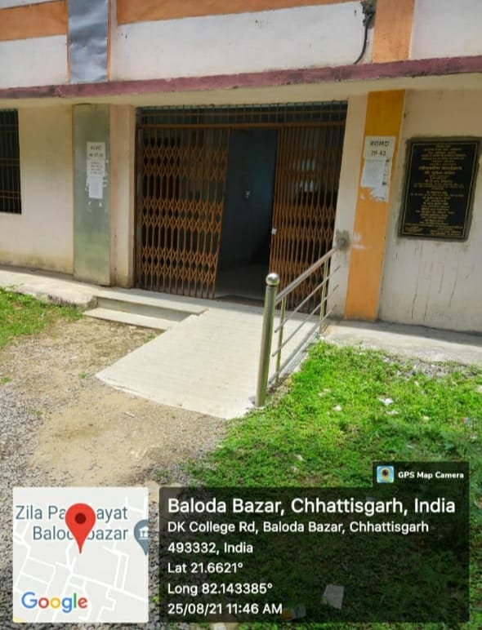

Divyangjan-friendly washrooms

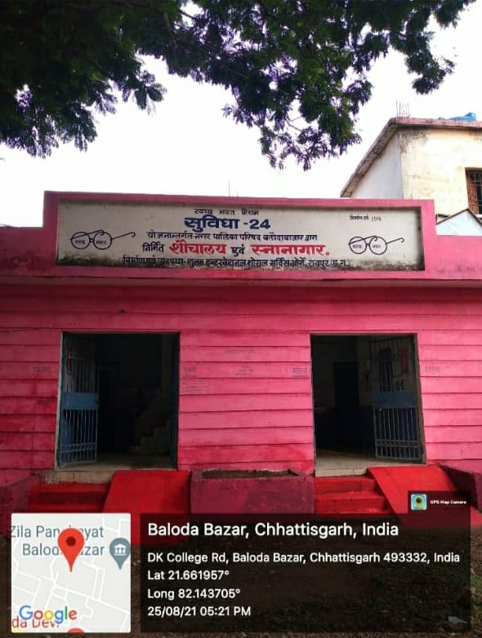

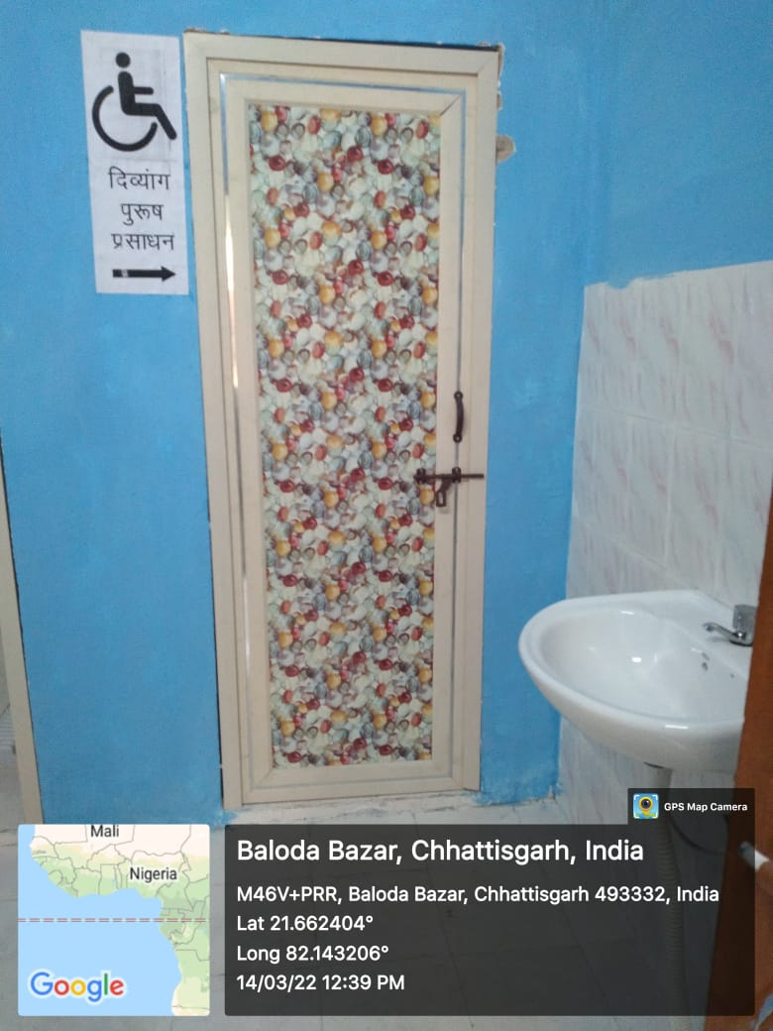

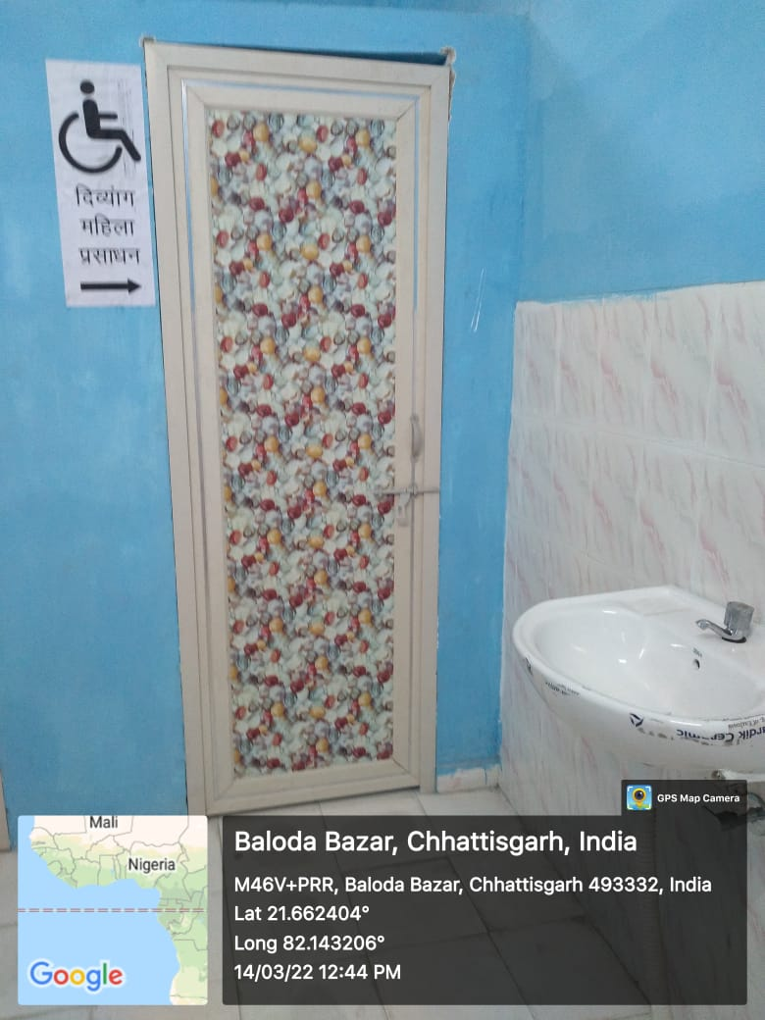

Divyangjan assessable mechanized equipment

