Government Dau Kalyan Arts & Commerce Postgraduate College, Baloda Bazar, Chhattisgarh

Key Indicator- 7.2 Best Practices

7.2.1 Describe two best practices successfully implemented by the Institution as per NAAC.

- Title of the Practice

Uniform

- Objectives of the Practice

Two best practices followed by our institution are first Uniform followed by the students of our institution. Uniform is not compulsory but the students of law, MSc Zoology, BSc IT, PGDCA and DCA with self motivated carry on uniforms. The uniform creates a health environment in the educational institution for study. Maintains a discipline in the college. Uniform establish a feeling of unity and uniformity

- The Context

For the above mentioned best practice of our institution faced some challenges also it was herculean task to motivate the students to carry uniform.

- The Practice
Discipline is the most important part each and every students and well discipline is example for good citizen. In college uniform is generally not compulsory, but in our institution it is practice that the students carry uniform which is by self motivation. It’s one of the unique feature of our college by this practice the education system had become more reproductive, and disciplined.

- Evidence of success
Students of our institution in uniform
LL.B./LL.M.
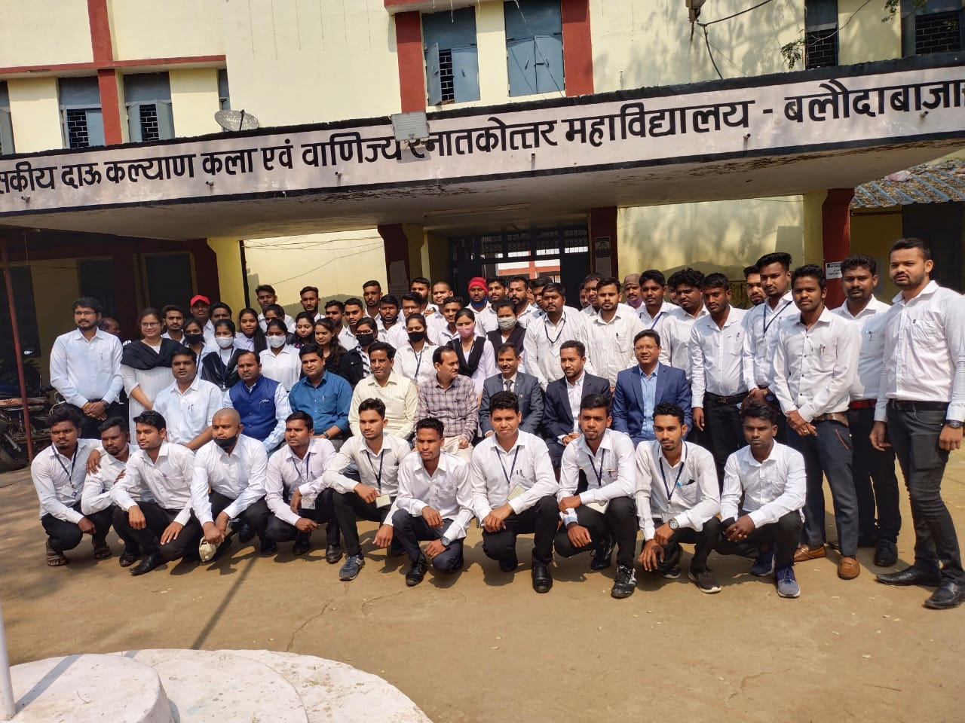
B.sc (IT)
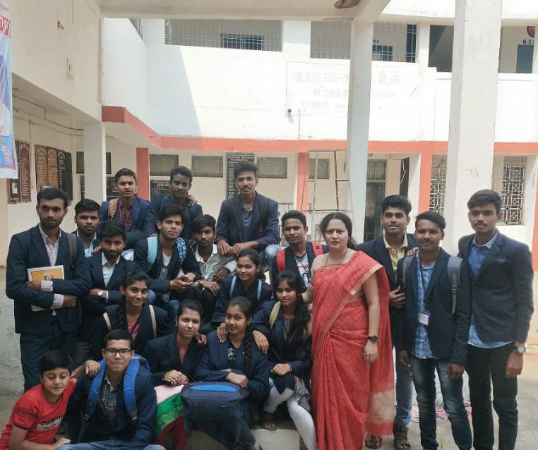

DCA/PGDCA
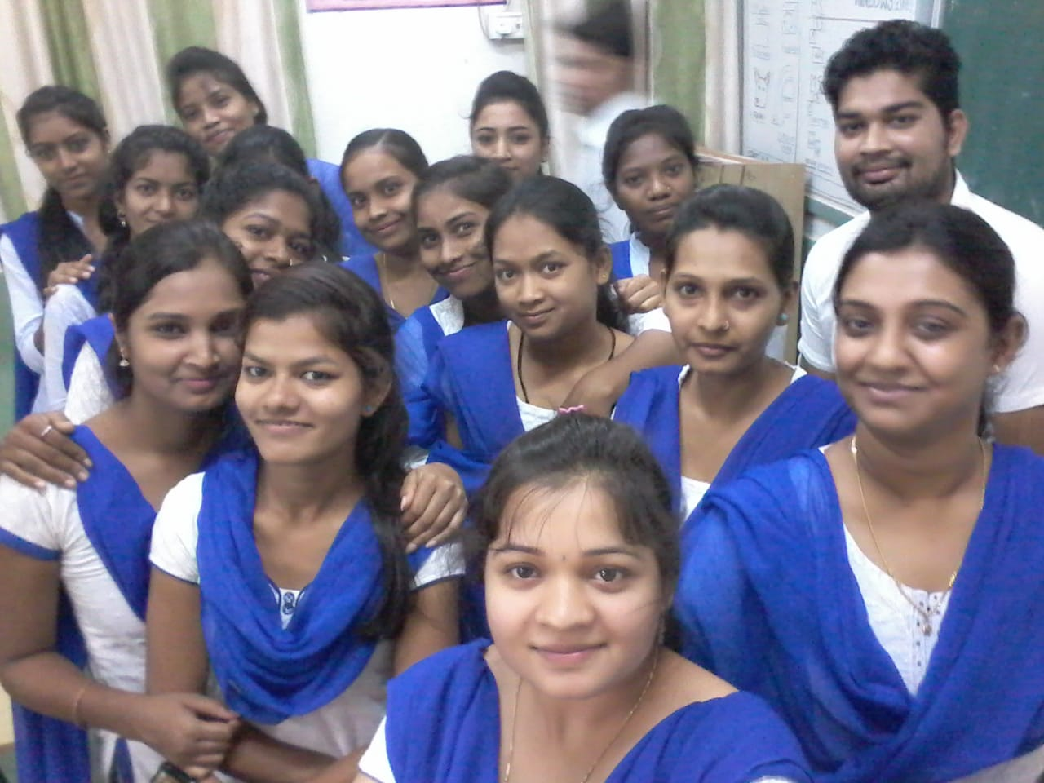
M.sc Zoology
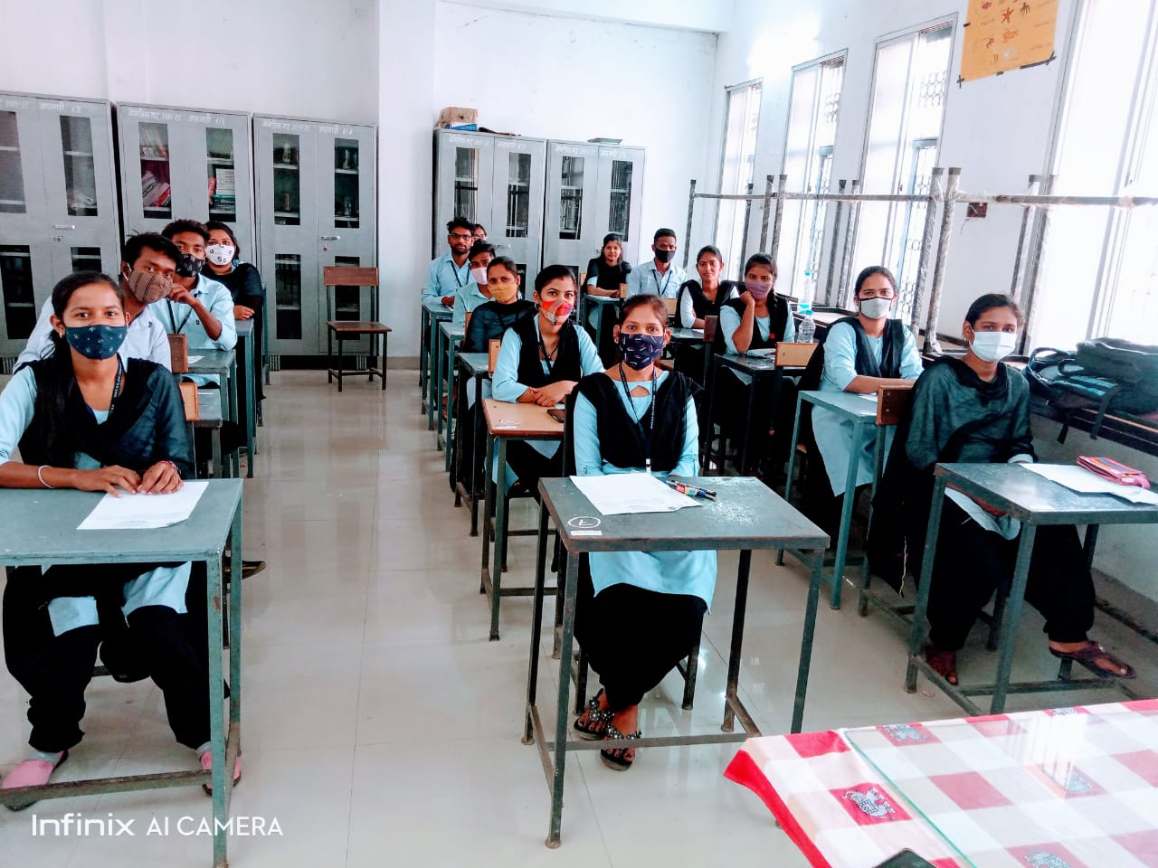

- Title of the Practice

Open gym

- Objectives of the Practice

In our institution open gym is established which is not only used by the students and staff but it is also used by the surrounding people living near to the college. This practice is making the people of Baloda Bazar fit and healthy. It is the object of the institution to make all people fit and healthy.

- The Context

For open gym there was lack of fund by the help of Nagar Palika this object was fulfilled.

- The Practice

There is old saying “when wealth is lost, nothing is lost; when health is lost, something is lost; when character is lost, everything is lost”. with these unique practice the college is trying to same something by giving the people opportunity to become fit and healthy by using the college open gym.

- Evidence of success

