Government Dau Kalyan Arts & Commerce Postgraduate College, Baloda Bazar, Chhattisgarh

7.1.4 Water conservation facilities available in the institution.

The Baloda Bazar District of Chhattisgarh had water shortage during summer as compared with other district of the state. For resolving the problem of the water shortage our institution had took the initiative of Rain water harvesting. During the rainy season there is abundant water available. Rain water is collected and stored. Rain water is collected from the roof of the institution redirected to tank (deep pit), so that it seep down and restore the ground water. In the institution for water distribution system bore well and open well is available but most of the water distribution is done through bore well system.
Rain water harvesting

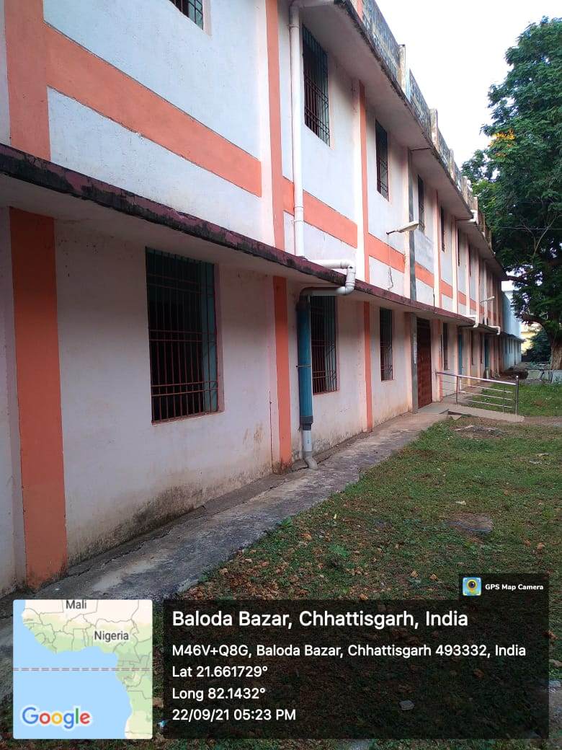
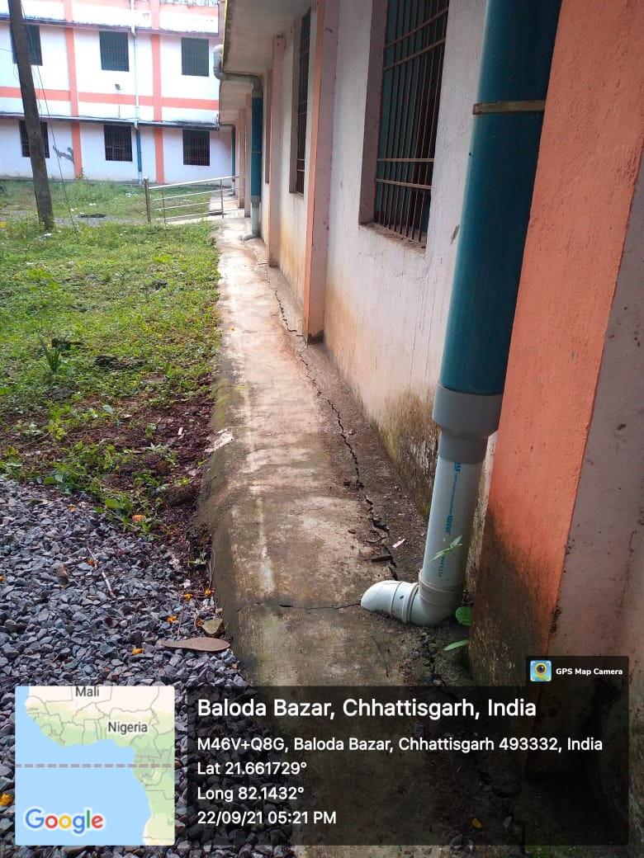
Bore well / Open Well recharge

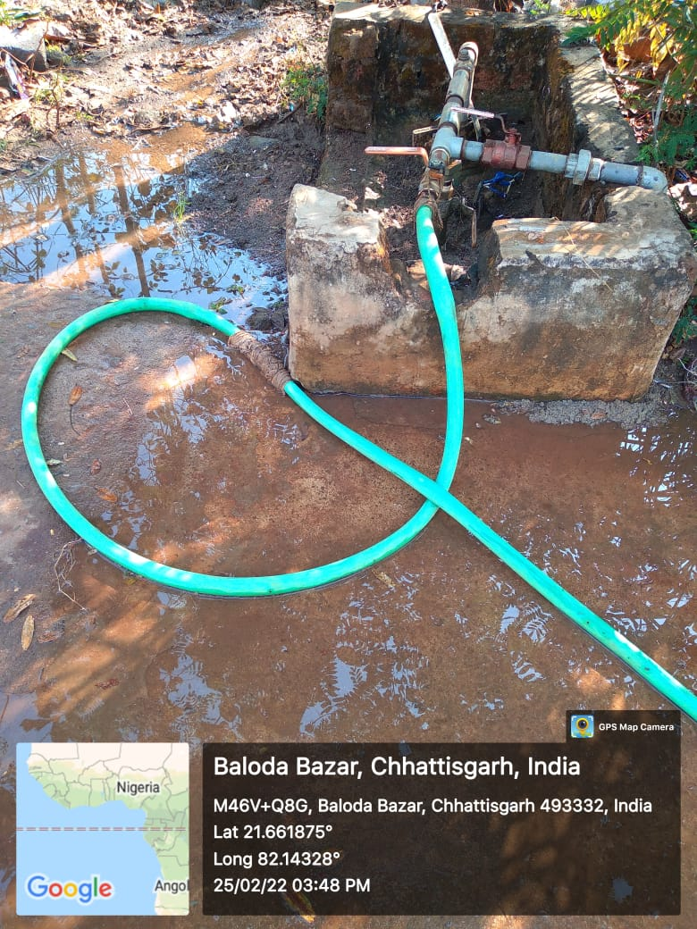

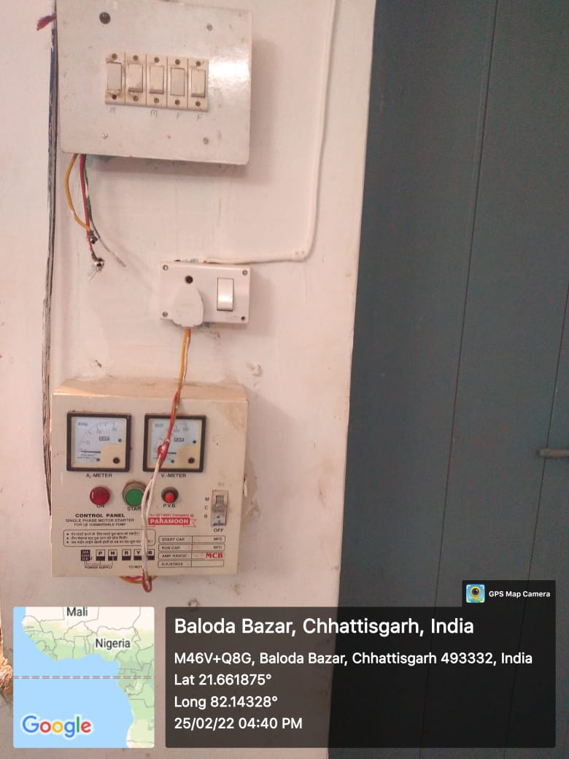
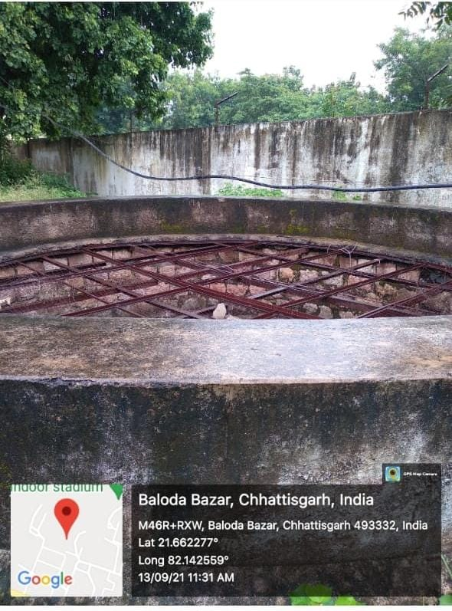

Water bodies and distribution system in the campus
