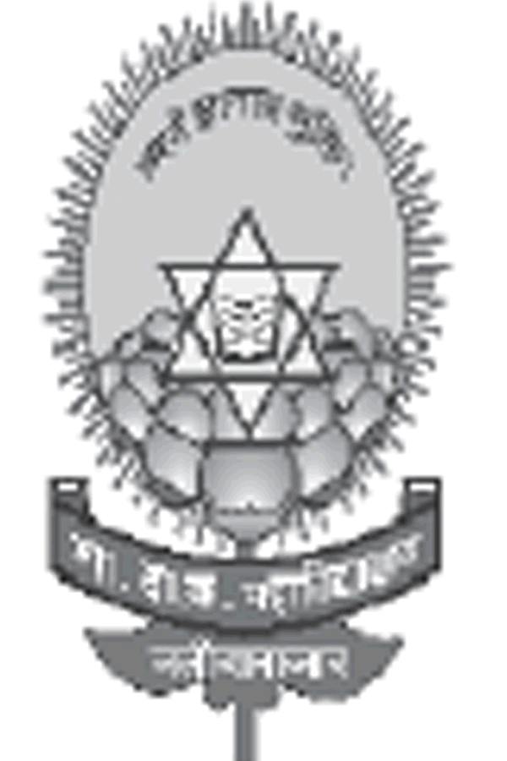
Government Dau Kalyan Arts & Commerce Postgraduate College, Baloda Bazar, Chhattisgarh

Inclusion and Situatedness
7.1.8 Describe the Institutional effort/initiatives in providing an inclusive environment i.e. tolerance and harmony towards cultural, regional, linguistic, communal socioeconomic and other diversities.
Government Dau Kalyan Arts & Commerce Postgraduate College is always ready to provide an inclusive environment i.e. tolerance and harmony toward cultural, regional, linguistic, communal socioeconomic and other diversities to fulfil these points in our institution students different religion, race, caste, sex, language, and place of birth are studying first of all the institution follows the C.G. State Government (Higher Education) Admission Reservation Policy according to which 32% of seats are reserved for Scheduled Tribes, 12% seats are reserved for scheduled Caste, 14% of seats are reserve for Other Backward Classes, 3% seats are reserved for freedom fighter family, 5% seats are reserved for Physical Handicapped and 5% seats are reserved for Kashmir Migrants.
To develop the emotional and religious feelings among the students and the faculty, commemorative days are celebrated on the campus with the initiative and support of college for not only recreation and amusement but also to generate the feeling of oneness and social harmony. The college and its teacher and staff jointly celebrate the cultural and regional festivals, like New-year’s day, Fresher Party ,teacher’s day, orientation and farewell program, Induction program, rally, oath, plantation, Youth day, Women’s day, Yoga day, festivals like Diwali Milan celebration, Holi Milan celebration, New Year celebration, etc. religious ritual activities are performed in the campus.
In this way the institute's efforts/initiatives in providing an inclusive environment for everyone with tolerance and harmony towards cultural, regional, linguistic, communal socioeconomic, and other diversities.

Type of Event | Date | Name of Event | Objective
Seminar | 5 December2016 | “Social Media –A Blessing or A Curse!” | Protection and prevention of women from sexual harassment.
Celebration | 27 November 2021 | Azadi ka Amrit Mohotsav | Understanding Nationalism and Patriotism among staff and students.
Workshop |  | Health Check Up | To make students of aware about heath and how it impacts the profession.
Celebration |  | Welcome | To make fresher comfortable and develop a free interaction.
Celebration | 26 November 2019 | Constitution Day | To bring awareness towards the respect for Indian Constitution.
Celebration | 8 November 2021 | Diwali Milan Samaroh
Seminar | 03 December  To  09 December 2019
Celebration |  | Welcome
Celebration |  | Annual day | Over all development of students.
Celebration |  | Annual Sports | Physical development of students.
Competition | 2016 | Rangoli | Development of co-curral activities among students

Effort/initiatives in providing an inclusive environment i.e. tolerance and harmony towards cultural, regional, linguistic, communal socioeconomic and other diversities.

